The Princess Bride
(through the eyes of a “shrink”)

- We will watch the entire movie together as a class
- You can click on the this link to have access to the entire screenplay (with stage direction) or this link for a screenplay (with only dialogue) for future reference
- Your job is to pick a character to diagnose and prepare a case presentation to the class. Click here to see one example of a case presentation.
  - Case presentations are essentially detailed analyses of a person that include details like:
    - Background information on the patient
    - Diagnosis – (Including definition)
    - Explanation of the reason for diagnosis, including family background, childhood and adult experiences, social and/or genetic factors, etc (for an example of a real case presentation click here)
    - Proof that your diagnosis is accurate – using quotes and scenes from the movie
    - Recommended course of treatment
      - You can pick any theoretical orientation you want in determining both diagnosis as well as treatment
- You case presentation will be graded on the following components (rubric to follow)
  - Creativity in determining the diagnosis
  - Depth of analysis (how much proof you have)
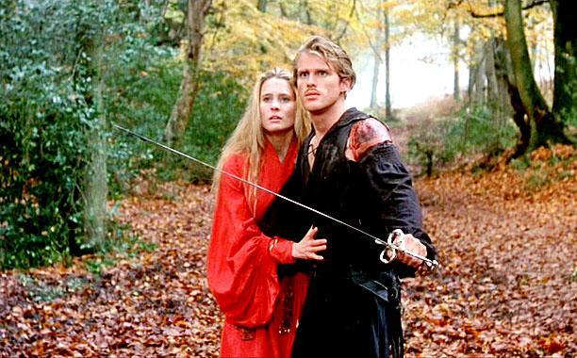
  - Use of multimedia and support materials in your case presentation

The Princess Bride – Through the Eyes of a Shrink
The Rubric
(out of max 80 pts)
 | 5 | 10 | 15 | 20
Accuracy | The diagnosis was wrong or the student could not defend his/her choice of diagnosis | The diagnosis was not the best choice but the student was able to make a coherent argument for his/her choice | The diagnosis was correct and the student defended his/her choice coherently | The diagnosis was correct and the student was able to explain other options that might fit, though not as well
Creativity of Presentation | The presentation was dry and no multimedia or visual cues were utilized | The presentation was creative and or entertaining, but no multimedia or other visual cues were utilized | The presentation engaged and captured the audience, brought in ideas not necessarily in the movie and the presenter used visual cues to help demonstrate his/her points | The presentation was engaging and captured the audience and the presenter used a mix of audio and visual cues to demonstrate his or her point, and took the story “outside of the movie”
Depth of Explanation | The presenter simply listed the characteristics of the disorder and showed how they connected to the character | The presenter demonstrated a knowledge of the disorder by giving examples to explain and clarify the characteristics of the disorder | The presenter showed good research of the disorder and was able to explain its etiology (its origin) and giving examples of how it might look in ppl other than his/her chosen character | The presenter was able to discuss the disorder from multiple psychological perspectives, explain how the different perspectives might explain the disorder for his/her character
Outside Knowledge | The Presenter used only information found in the textbook | The presenter used psychological material from sources other than the text book (i.e. from class) | The presenter used information not only from what we learned in class, but from outside sources as well | The presenter used outside sources to bolster his/her argument and provided citations of the sources of the information

